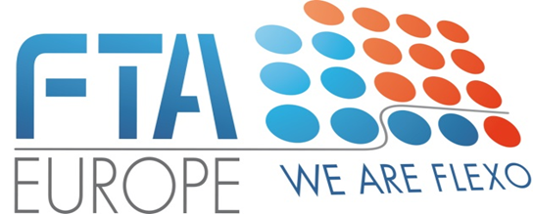

**Flexo Best Practice Tool-Box – Agreement for support**

We …………………….. [hereafter “the company”] agrees and commits to support the Flexo Best Practice Tool Box Project led by FTA Europe as indicated in the letter and the attachment explaining all the conditions and benefits of support.

Therefore, the company confirms commitment to pay the amount of **4.000 €** to support the regular development of the project. Moreover, the company ensures to contribute to the final preparation of the Guidelines by providing technical contributions.

The present letter is signed and forwarded to FTA Europe at [lconti@fta-europe.eu](mailto:lconti@fta-europe.eu) .

Faithfully,

Date …..

Signature of the Company ……